**Predicting the best location to open Restaurant in Lahore**

* 1. **Description of Problem:**

Lahore is one of the biggest cities in Pakistan. It is especially famous for its food. However, restaurants are located in certain hubs of the city where locals and travelers prefer to eat generally. A potential investor in food business wants to know the best location to open a new restaurant in Lahore.

* 1. **Description of Data:**

The list of restaurants, their location, their address, their latitude and longitude coordinates is extracted using four square ID. The extracted data is then converted to panda data frames. Then using restaurant’s longitude and latitude coordinates they are represented on Folium maps. Using that it is concluded which locality of Lahore is best for opening restaurants.

* 1. **Methodology:**

Below steps have been utilized to predict best location to open a new restaurant in Lahore.

Step1: Longitude and latitude coordinates of Lahore are utilized and four square logarithm is run to acquire data of restaurants of Lahore

Step2: Data is cleaned, normalized and represented in a data frame

Step3: Using folium maps; restaurants are represented on Lahore’s map and their location is visible by blue markers

* 1. **Results:**

**1.4.1:** Table Head Data frame showing list of restaurants in Lahore:

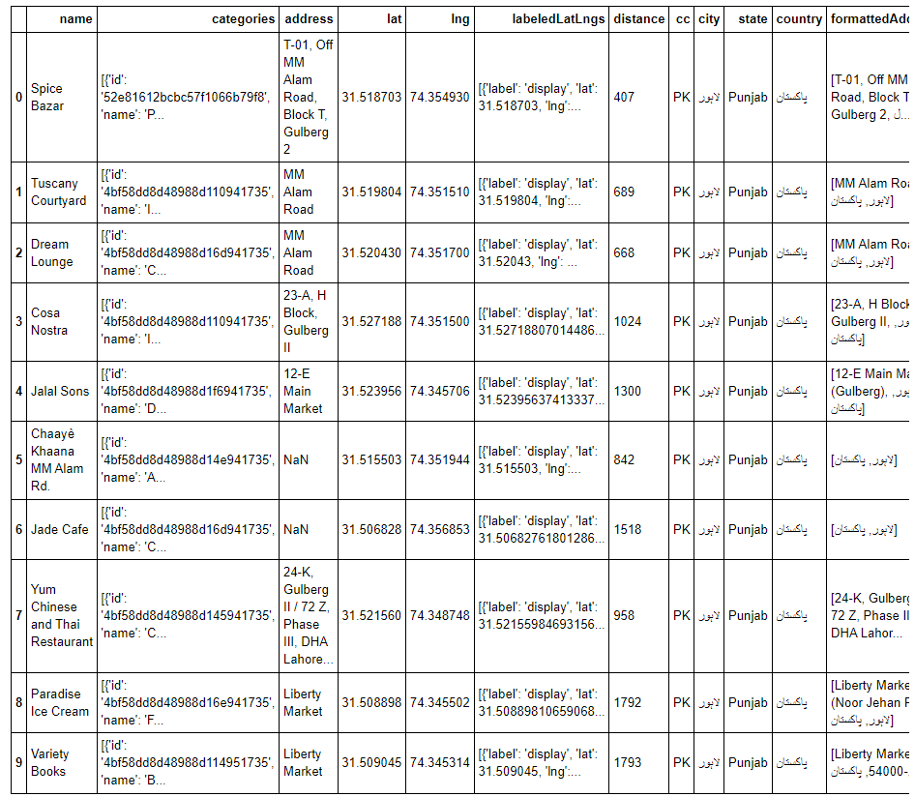

**1.4.2:** Folium Map showing most restaurants are located in Gulberg

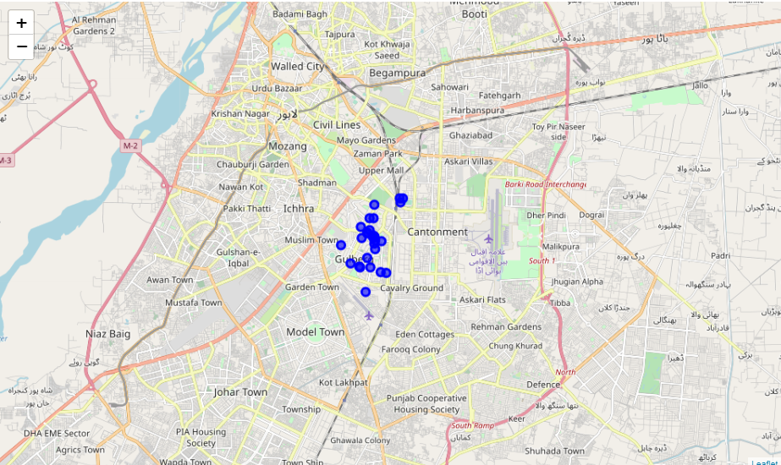

**1.4.3:** Empty Folium Map

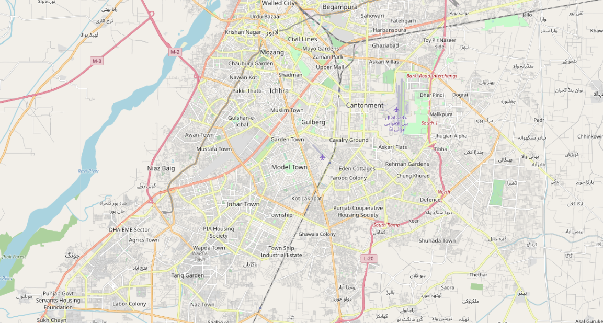

**1.5:** **Observation and Recommendations:**

Being born in Lahore I am personally well versed with locations that will be hot for new restaurants. Gulberg as identified by the data, is definitely the prime location to open up a new restaurant. However, Lahore is famous for its street food and small restaurants; this data does not account for hubs of those small restaurant areas as those restaurant coordinates must not be available in four square API.

Gulberg as identified is a prime location to open up a new restaurant for big investors as it is an expensive area however a small investor cannot rely on this model to open up a new restaurant. With time, four square API shall keep on adding newer restaurants and analysis of smaller restaurant shall also become available by this method.

**1.6:** **Conclusion:**

The four square API and algorithm has correctly identified gulberg as the ideal location to open up a new restaurant. Though this prediction is marred by lack of locations available with four square API but with the current amount of data the prediction is 100% correct.